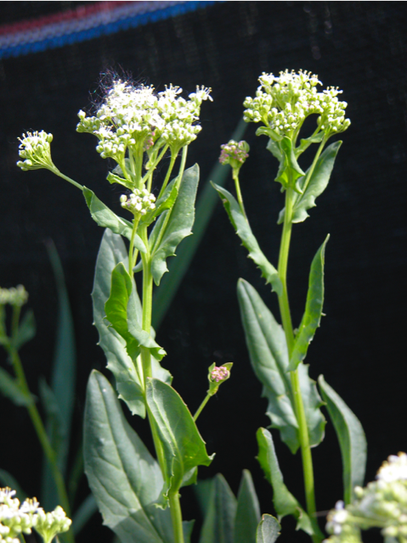

**Hoary Cress (Cardaria draba)**

Hoary cress, also known as “White top,” is a member of the Mustard family.  It was probably introduced from Europe as a contaminant in alfalfa seed.  It is a creeping perennial, which means it reproduces by seed and creeping roots.  The extensive root system spreads horizontally and vertically with frequent shoots arising from the rootstock. The aggressive nature of this plant allows it to out-compete and displace native species. It grows erect from 10 to 18 inches high and has a bluish green colored leaf.  The flowers are white and numerous in compact flattop clusters which give the plant its name. Hoary cress is one of the earliest perennial weeds to emerge in the spring, producing flowers in May or June.  It grows in waste places, cultivated fields, and pastures, and is capable of vigorous growth. This plant is rapidly spreading throughout Pitkin County, especially around the Shield-O -Mesa and surrounding areas. **Early control is recommended before seeds set in June.**