Canada Thistle (Cirsium arvense)
Canada thistle is a member of the Aster family. The actual name, Canada thistle, is a bit misleading, because it is not native to Canada, or anywhere else in North America for that matter. It came over from Europe and now is one of the worst weeds in the Northern United States. It is a creeping perennial, which reproduces by seeds and roots. The erect stem is hollow, smooth and slightly hairy, 1 to 5 feet tall, simple, and branched at the top. The color is primarily lavender, pink, or purple. Canada thistle emerges in June in most parts of Pitkin County. It is one of the most widespread and economically damaging noxious weeds in Colorado. Infestations are found in cultivated fields, riparian areas, pastures, rangeland, forests, lawns and gardens, roadsides, and in waste areas. Because of its seeding habits, vigorous growth, and extensive underground root system, control or eradication is difficult. Canada thistle can be distinguished from other thistles by its size: it usually only reaches knee high in most parts of Pitkin County. Its flowers are also a paler pink color.

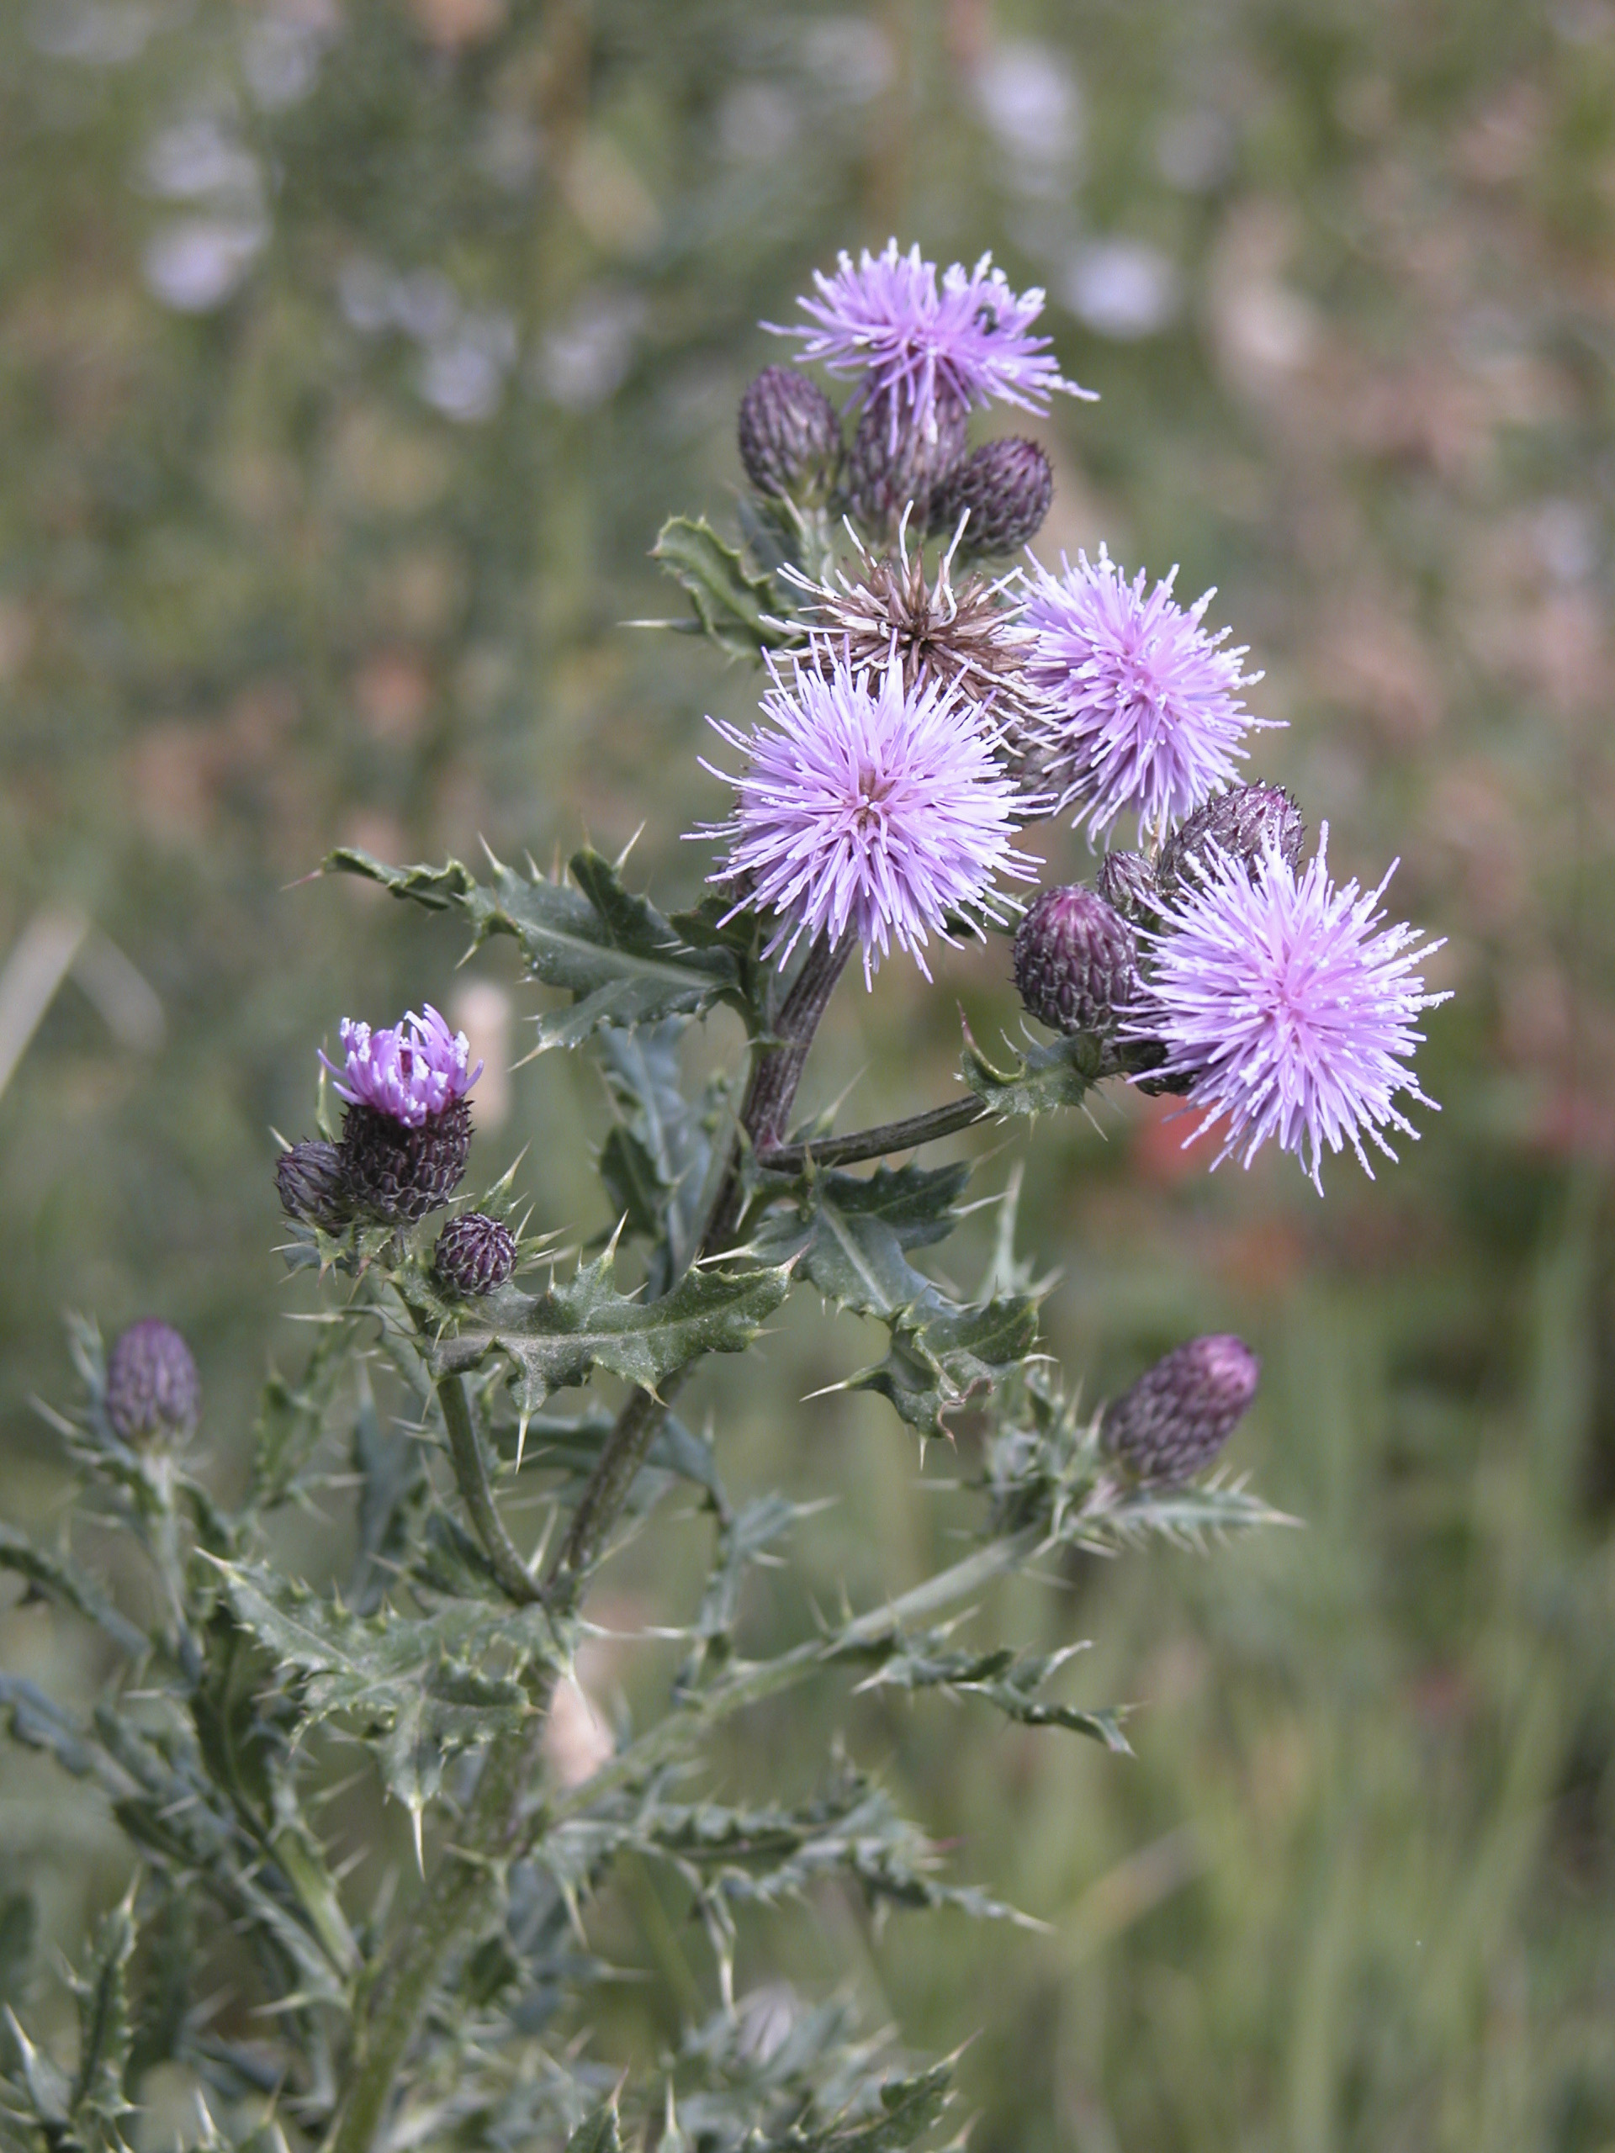

For additional information, contact Pitkin County Land Management at 920-5214 or the City of Aspen Parks Department at 429-2026.

